**The information in this briefing package is unclassified**

**Executive summary.** It is April 29th, 2011. You have been asked to evaluate the feasibility of a performing a mission of national security importance.

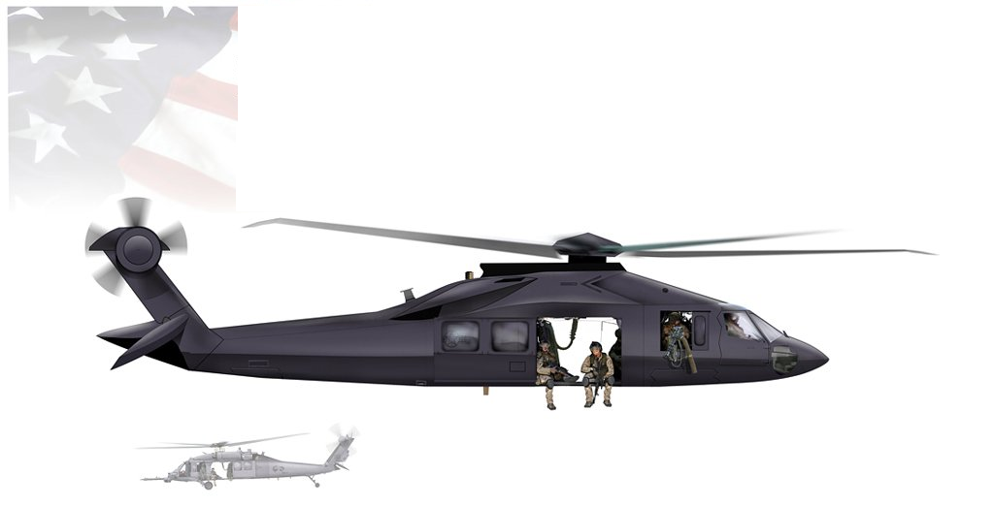

**Background**

The “Khaki Chew Ball” (KCB) is a reconnaissance-in-force transportation vehicle used by the U.S. Government (the “Customer”) to deliver mission specialists to target locations. The original engineering prototype KCB was developed in December 2001, and the prototype successfully completed three test flights (May 2002, November 2002, and January 2003). After the prototype missions were complete, the Customer subcontracted production of KCB’s to the “OneBig” Company, giving the Company an exclusive contract for the first 25 missions. The first mission was conducted by the Company in July 2006; there have now been twenty-four KCB missions completed. The latest mission (“Operation Cold Case”) was conducted on 4/6/2011. The list of past missions is given below.

|  |  |  |  |  |  |  |
| --- | --- | --- | --- | --- | --- | --- |
| Mission | Code | Date |  | Mission | Code | Date |
| 1 Cole Slaw | 5-A | 7/15/2006 |  | **13 Charred Remains** | 14-G | 1/7/2010 |
| 2 Colonel Sanders | 6-E | 2/14/2007 |  | **14 Discolored Fruit** | 15-A | 2/10/2010 |
| 3 Collective Wisdom | 7-F | 6/24/2007 |  | **15 Diseased Mind** | 15-C | 4/28/2010 |
| 4 Colgate Crest | 8-B | 9/29/2007 |  | **16 Disk Drive** | 15-D | 7/15/2010 |
| 5 Coloring Book | 9-E | 2/13/2008 |  | **17 Champion Trophy** | 15-B | 8/1/2010 |
| 6 Chafed Elbows | 10-A | 7/6/2008 |  | **18 Displayed Plans** | 15-G | 9/19/2010 |
| 7 Chasing Ghosts | 11-C | 9/19/2008 |  | **19 Changing Paradigm** | 15-F | 10/31/2010 |
| 8 Channeled Anger | 12-D | 12/1/2008 |  | **20 Distant View** | 15-I | 11/29/2010 |
| 9 Column Formation | 13-E | 3/31/2009 |  | **21 Atlantic Hurricane** | 15-J | 1/5/2011 |
| 10 Charted Course | 14-B | 5/7/2009 |  | **22 Chapped Hide** | 16-A | 2/1/2011 |
| 11 Chatty Courier | 14-C | 7/9/2009 |  | **23 Atlas Shrugs** | 16-B | 2/28/2011 |
| 12 Disco Tango | 14-D | 12/2/2009 |  | **24 Cold Case** | 16-C | 4/16/2011 |

Note: “date” refers to date that mission was actually conducted, not scheduled date of mission.

**Competitive situation**

With each completed mission, the Company’s market value (as measured by its stock price multiplied by the number of outstanding shares) has increased (albeit with some random fluctuation, especially at the start of the KCB program). At the time of the first mission, the Company was worth only $860M; now, after 24 successfully completed missions, the Company’s value has almost doubled to almost $1.7 billion.

**Market value of the Company ($M), by Number of Completed Missions**

|  |  |  |  |  |  |  |  |  |  |  |
| --- | --- | --- | --- | --- | --- | --- | --- | --- | --- | --- |
| Mission | Value |  | Mission | Value |  | Mission | Value |  | Mission | Value |
| 1 | 860 |  | 7 | 1202 |  | 13 | 1351 |  | 19 | 1604 |
| 2 | 609 |  | 8 | 949 |  | 14 | 1450 |  | 20 | 1664 |
| 3 | 473 |  | 9 | 1136 |  | 15 | 1513 |  | 21 | 1616 |
| 4 | 390 |  | 10 | 1075 |  | 16 | 1545 |  | 22 | 1612 |
| 5 | 761 |  | 11 | 923 |  | 17 | 1548 |  | 23 | 1651 |
| 6 | 1009 |  | 12 | 1364 |  | 18 | 1543 |  | 24 | 1686 |

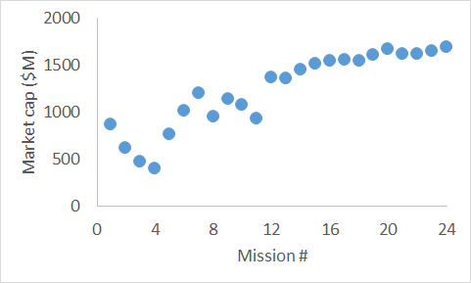

To further increase its market value, the OneBig Company has promised the Customer another two dozen missions at a rate of one mission every two weeks. The Customer believes that missions like those performed by KCB’s could be the basis for operations in the future, and the Customer has stated their intention to perform another 100 to 150 missions over the next several years. However, it is not clear that the OneBig Company will be the beneficiary of those future missions; because of some delays on previous missions, it is believed that the Customer has started to quietly explore alternatives with competitors, and possibly not using KCB’s any more. Since the KCB product line represents 40% of OneBig’s revenue, having the Customer cancel KCB contracts would result in a multi-million drop in the market value of the OneBig Company.

Competitive intelligence indicates that the “Homeland Ticker” Company is developing its own vehicle as a competitor to the KCB, but the competitor vehicle (the “Extended Stealth Aircraft”, or ESA) is not expected to be ready for large-scale deployment until another year or two.

**Mission #25. “Operation Chalk Outline”**

Mission #25 (15-L, “Operation Chalk Outline”) is scheduled for May 2, 2011. Mission #25 is a mission into an undisclosed location in Pakistan, 163 miles from the staging airbase at Jalalabad. Flight time will be 90 minutes. The Customer is willing to pay $401M if the mission is successfully conducted on time, which represents a 15% profit margin on the $349M that has already been spent preparing for the “Chalk Outline” mission.

The Homeland Ticker Company has offered to send its prototype ESA to the location, but the ESA vehicle will not be ready for another week; so if “Chalk Outline” launches on time, the OneBig Company will be able to conduct the mission before the competition has the opportunity.

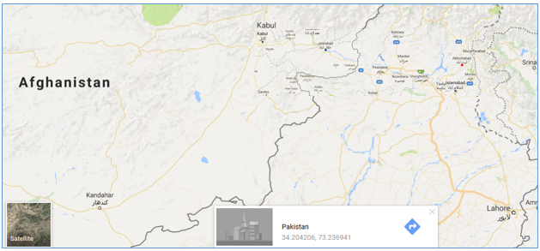

**Your assignment.** You have been asked to provide a cost-benefit analysis for Mission #25. Your analysis should include (at least) three aspects of the mission: the possible benefit for completing the mission as scheduled, the costs associated with delaying or cancelling the mission, and the risk associated with performing the mission as scheduled. You should also include a clearly-stated final recommendation.

**Engineering for the KCB**

The Silent Trough panel

By design, each KCB vehicle has two “silent trough” (ST) panels that absorb radar signals and isolate the engine and the fuel tanks. Each ST panel has a cross-section of 40.91 square inches with a depth of 2.78”, made from a polymer resin; if both panels were to develop leaks, so that fuel could escape into the engine in an uncontrolled fashion, the fuel tank would ignite, killing the flight crew and passengers. (Operation Chalk Outline will have a pilot, a co-pilot, and five mission specialists from a Customer division known as “Taxi Measles”.)

**Illustration of KCB “silent trough” panel**

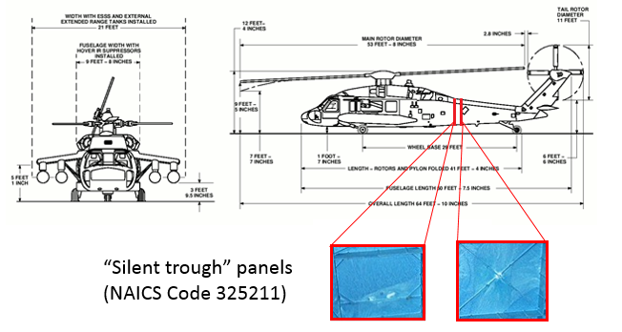

Testing ST panels before each mission

Over the years, the Company performed more and more rigorous “proof testing” to make sure the panels are good enough for use. Before any panel is installed, it is put through a high pressure stress test, where the panel is subjected to high stress and then tested for leaks; if no leaks are detected, the panel is installed for use on a KCB. No panel has ever failed the pre-mission leak test. In the past, panels were tested to 50 psi (pounds per square inch); recently, the panels have been tested to 100 psi and 200 psi, for extra confidence in the strength of the panels. The panels on Mission #25 have been tested have received the highest testing, at 200 psi. (Missions 1 through 7 were tested at 50 psi; missions 8 and 9 were tested at 100 psi; and missions 10 and onwards have used the improved testing at 200 psi.)

Inspecting ST panels after each mission

After every mission, both panels are removed and subjected to Destructive Physical Analysis (DPA), in which each panel is carefully cut up to check for damage. The DPA cross sections are available in the Appendix.

After the KCB was deployed in the field, it was discovered that some panels had developed “pits”, partial cracks that had penetrated some depth into the panel. None of the 48 panels ever developed a leak that went all the way through the panel, but six of the 48 panels had “pits”, ranging from 0.04” deep to 0.53” deep into the 2.78” panel. A structural analysis indicates that the panel should be able to prevent leaks as long as no “pit” exceeds 0.95”.

**Part One. Cost-Benefit Analysis**

1. **Financial analysis of benefit of completing missions**
2. Data are available for the market value of the company as a function of number of missions completed. Take the data and use X = “mission number” to predict Y = “market value of the company ($M).” What is the T-value for the slope? Is the T-value “statistically significant?”
3. Based on your model in #1, what is a 95% confidence interval for the change in market value associated with every additional mission? Round your answer to the nearest dollar.
4. Based on your model in #1, what is a 95% prediction interval for the market value of the company after successfully completing 25 missions?
5. **Estimating cost of delay**

Ten (10) of the 24 missions experienced delays before launch, and Wall Street analysts believe that the delays have had a profound negative impact on the market value of the company. One analysis (that the CEO has sent out to the Company at large) was as follows: for each mission, compute the “average delay per mission” (defined as the total sum of all delays up to and including that mission, divided by the number of missions); then, use “average delay per mission” to predict the market value of the company. For example, for mission #1, the “average delay per mission” was 2 days / 1 mission = 2 days, and market value after mission #1 was $860M; for mission #2, the “average delay per mission” was (2+30 days) / 2 missions = 16 days, and the market value after mission #2 was $609M; etc. The analyst removed the first five data points from the analysis (citing the large volatility in market value during the early days of the Company), and used the remaining 19 data points for the analysis.

1. Use the 19 most recent data points and use X = “average delay per mission” to predict Y = “market value.” Based on this information, what is a 95% confidence interval for the impact of having “average delay = 1 day” versus “average delay = 0 days”? Round your answer to the nearest dollar.
2. Based on this same analysis (and the same 19 points), what is a 95% confidence interval for the expected value of the market value of the company if there had been no delays in any of the 24 missions? Round your answer to the nearest dollar.
3. A second analyst performed the same analysis, except that she only used the last 13 data points, saying those data were the most relevant and the most stable. What is R2 value for this analyst’s model?
4. **Estimating risk**

Engineers at the OneBig Company and at an independent consulting company (the “Coarse Ape” Consulting Company, or CA) have performed risk analyses.

First, it was questioned why “pits” developed in the first place. An engineer speculated that “pits” might be related to flight time, since longer flight times result in higher temperatures (thermal analyses indicate that initial operation brings the panels to 250oF, and every minute of flight time increases the temperature by 2oF to 3oF or so), but it is not clear that if there is any relation. Data for the six panels with “pits” are given below.

**Data for six panels that had “pits”**

|  |  |  |  |
| --- | --- | --- | --- |
| Mission | Flight time (minutes) | Test pressure (psi) | Depth of pit (inches) |
| 6-E fore | 40 | 50 | 0.53 |
| 14-B aft | 62 | 200 | 0.40 |
| 14-D fore | 49 | 200 | 0.28 |
| 15-C fore | 66 | 200 | 0.38 |
| 15-C aft | 66 | 200 | 0.10 |
| 16-C aft | 61 | 200 | 0.04 |

1. For the six panels listed in the table above, flight times varied from 40 minutes to 66 minutes. For the data above, what is the correlation between flight time and depth of pit? Is the correlation “statistically significant”?

Independent analysis by CA Consulting

A reliability engineer at CA developed an approach to estimating risk. Her risk analysis is as follows:

* Divide the depth of the panel into five “zones”, each with thickness 2.78” / 5 = 0.556”.
* In 24 missions, there have been 24*2*5 = 240 “zones” (24 missions, 2 panels per mission, 5 zones per panel), and no “zone” has ever had a crack as long as 0.556”.
* The loss of a single “zone” would not cause failure; for a panel to have a leak, there must be at least two “zones” that fail on that panel.
* The chance that the fore panel has two “zones” leak and that the aft panel also has two “zones” leak is small enough to be ignored.

1. If the chance of a “zone” leaking is the same every time from “zone” to “zone”, what is the 90% upper confidence limit for the chance that a “zone” has leak, based on 0 failures in 240 independent trials?
2. Based on your answer for 9., what is the chance that a panel with five independent “zones” would have two or more “zones” that leak?

Analysis by Engineer at OneBig

A senior engineer at the OneBig Company created a more complicated “two-stage” model to estimate the risk. He says, correctly, that a failure requires four things must happen:

* The fore panel needs to have a “pit” or crack
* The “pit” in the fore panel needs to be larger than 0.95”
* The aft panel also needs to have a “pit” or crack
* The “pit” in the aft panel also needs to be larger than 0.95”

The engineer says that the chance that all four things happen must be very low.

1. There were six panels in 48 that had “pits.” Assuming that all missions are equally likely to develop pits, what is a 95% confidence interval for the probability that a panel develops a “pit”?
2. The n=6 data points had an average penetration depth of 0.2883 inches and a standard deviation of 0.1879 inches. For a normal random variable with expected value of 0.2883 and standard error of 0.1879, what is the chance that a randomly-chosen value will exceed 0.95?
3. The calculation in 11. is based on assuming that the standard error was 0.1879. However, the 0.1879 was the sample SD, based on a sample of size n=6. What is the upper 90% confidence limit for the population standard deviation (still assuming that the sample SD was 0.1879 from a sample of size 6)?

The engineer’s assessment of risk is P(fore panel has “pit”) * P(pit in fore panel > 0.95”) * P(aft panel has “pit”) * P(aft in fore panel > 0.95”) and concludes that the risk is very low.

**Part Two. Independent Risk Analysis**

Before a mission can be conducted, the Company must provide a formal recommendation. Prepare a one-page summary of your recommendation. Your summary should include a clear statement about the risk of the mission, your recommendation (“use as is”, “delay”, “cancel”), and the rationale for your decision. Relevant factors to include would be whether flight time has an effect on mission risk, the fact that each KCB has two plates, and the fact that the plates on Mission #25 has received the improved testing of plates. A draft “Engineering Assessment” provided by CA has been attached. You should mention whether you agree or disagree with the analyst at CA and/or the senior engineer at OneBig.

The CEO is also interested in the financial implications of your recommendation. If you recommend delaying or cancelling the mission, include an estimate of how long a delay you recommend, what you would do with the additional time, and the estimated cost of your decision (in terms of market value). If you recommend cancelling the mission, provide a rationale why you are recommending taking a $349M loss, and estimate the impact to the market value of the Company. Also note that delays longer than one week will give the Customer the option to cancel the mission, resulting in the $349M loss to the Company. If you recommend proceeding with the mission, provide a financial assessment associated with the risk that the Customer rejects your recommendation (and thus requires that you absorb the $349M loss). Per Customer guidelines, a mission risk of less than 1 in 10,000 is considered “safe”, and a risk of 1 in 100 would be considered “unacceptable risk”; mission risks between 1 in 100 and 1 in 10,000 are evaluated on a case-by-case basis, and you may assume that the chance the customer rejects a “use as is” recommendation is “100 * (calculated probability of mission failure)” … so a “use as is” recommendation accompanied by a risk of “1 in 100” (or higher) would have a 100% chance of being rejected by the customer, and a “use as is” recommendation accompanied by an analysis showing mission risk is “1 in 10,000” would have a 100*(0.01%) = 1% chance of being rejected by the customer.

The contract with the Customer includes an indemnity clause: in the case of a failed mission, the Company’s legal liability is capped at $10 million; i.e., the amount that the Company would have to pay in damages has a maximum value of $10 million. The actual amount the Company would pay in case of failure has never been tested, however, since no mission has ever failed.

1. As an independent analyst, do you agree or disagree with the analyst from CA? Do you agree or disagree with the engineer at OneBig? (You will have a chance to explain your reasoning in your Microsoft Word writeup.)
2. Based on your own look at the data, what is the risk of mission failure be for “Operation Chalk Outline”? You may use whatever methodology you think appropriate (but you will discuss your methodology in your Microsoft Word writeup).
3. After reviewing questions 1 through 14, what is your recommendation for Mission 25?

**Instructions.** You will mail two items. First, fill out the appropriate Excel template. Second, include a one-page (maximum) write-up to the CEO, using Microsoft Word. Remember that the CEO is a busy man; be sure your recommendations are clear, and your explanations are compelling. Do not use font smaller than 12 point font. You may include charts or graphs, as long as they fit on the page. The CEO is primarily a businessman and is interested in financial results, but you may assume the CEO has a working knowledge of statistics. Once you are satisfied with your Excel sheet and Microsoft writeup, mail both to [tony_statman@yahoo.com](mailto:tony_statman@yahoo.com) Word recommendation with subject line “GSBA545 Project03 for [your name]”.

**Independent Risk Assessment from “Coarse Ape” Consulting**

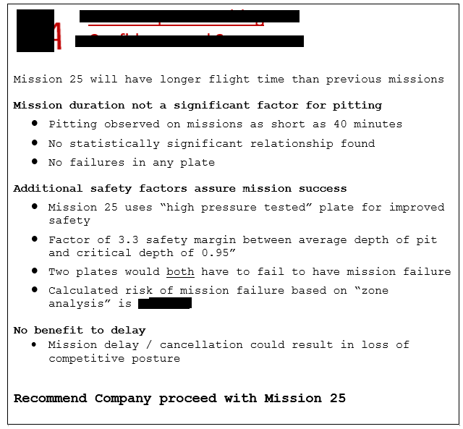

**List of Mission Flight Times (one way-flight time, minutes) for 24 Completed KCB Missions**

|  |  |  |  |
| --- | --- | --- | --- |
| Mission # | time | Mission # | time |
| 15-F | 38 | 15-G | 49 |
| 8-B | 39 | 7-F | 50 |
| 15-J | 40 | 9-E | 51 |
| 15-I | 43 | 10-A | 52 |
| 16-B | 43 | 14-G | 52 |
| 15-B | 44 | 15-A | 52 |
| 16-A | 44 | 15-D | 52 |
| 12-D | 46 | 5-A | 53 |
| 11-C | 47 | 14-C | 56 |
| 6-E | 49 | 16-C | 61 |
| 13-E | 49 | 14-B | 62 |
| 14-D | 49 | 15-C | 66 |

**10 KCB Missions with Schedule Delays**

|  |  |  |  |  |
| --- | --- | --- | --- | --- |
| Number | Mission Name | Scheduled | Actual | Delay |
| 6 | Chafed Elbows | 5/7/2008 | 7/6/2008 | 60 |
| 12 | Disco Tango | 10/13/2009 | 12/2/2009 | 50 |
| 2 | Colonel Sanders | 1/15/2007 | 2/14/2007 | 30 |
| 24 | Cold Case | 3/17/2011 | 4/16/2011 | 30 |
| 9 | Column Formation | 3/3/2009 | 3/31/2009 | 28 |
| 19 | Changing Paradigm | 10/17/2010 | 10/31/2010 | 14 |
| 20 | Distant View | 11/26/2010 | 11/29/2010 | 3 |
| 1 | Cole Slaw | 7/13/2006 | 7/15/2006 | 2 |
| 14 | Discolored Fruit | 2/9/2010 | 2/10/2010 | 1 |
| 15 | Diseased Mind | 4/27/2010 | 4/28/2010 | 1 |

**DPA results for six panels with pits**

